JS-IP4S-006 iPhone 4/4S Tripod Stand Case

The iPhone is a piece of equipment that needs protection to keep it looking good, using a case from Jison is a great way to keep it looking in pristine condition. However sometimes the iPhone is used as a mobile entertainment center and Jison has developed a case that allows you to watch video or make camera calls while remaining hands free.
The JS-IP4S-006 iPhone 4/4S tripod stand case is by far one of the most innovative products on the market today.
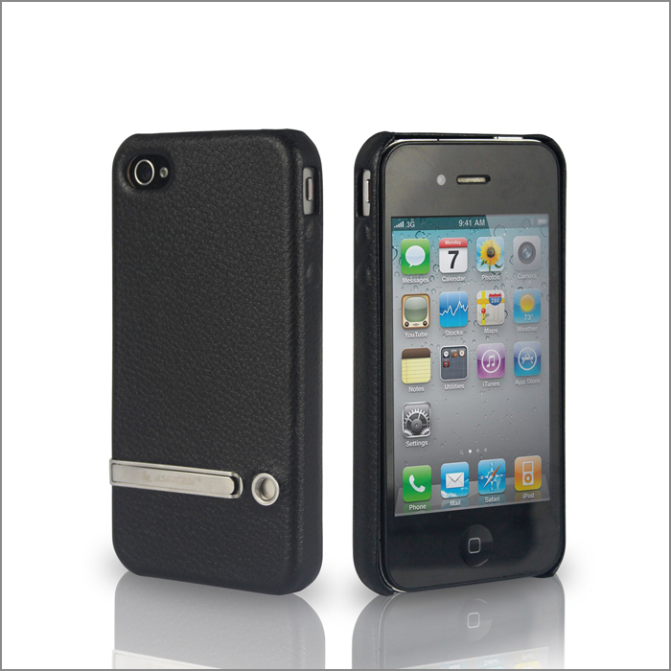
It is similar in design to the very popular slim fit case but when you examine this case closely you will see some marked improvements. This case is aimed at people who enjoy watching videos and taking photographs with their iPhone. It arrives in packaging exactly the same as the slim fit case, which is a brown cardboard sleeve and a cardboard insert that slides from the sleeve using the handily placed string handle that is used for shop display purposes.
The case itself is well made and has a genuine feel of quality, looking at the back of the case there is a round screw thread insert that allows for the attachment of a tripod.
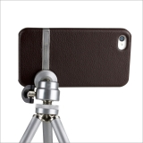

Also if you enjoy watching films or music videos on the move, there is a small metal insert that extends outwards to enable the iPhone to stand free while the film is being viewed. Although the stand itself feels delicate, if it is used correctly then it will remain fit for the function for which it was designed. There is one cutout on the back of the case that leaves the lens of the rear facing camera open and readily available.
There is a cutout on the side that allows easy access to the camera shooting button with indentations for the volume controls on the iPhone just below this.
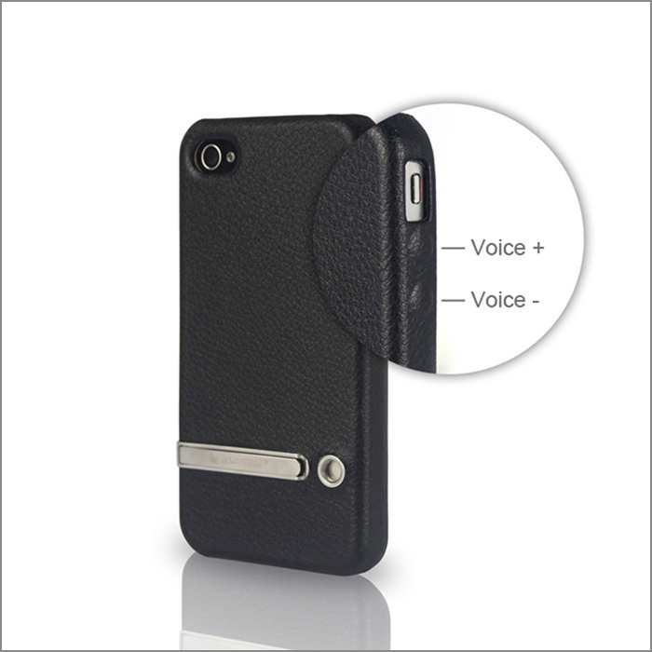
The range of colors offered is not as extensive as the popular slim fit case with just half of the colors available. As with the slim fit case the edging shows no sign of stitching and feels firm and sturdy, the inlay giving the case that added rigidity. Fitting the phone in the case, is just a simple matter of slotting it in, all of the ports are easily accessible so that charging and earphones can be utilized without the need of removing the case.
The leather finish of this Jison case will stay looking good for the entire lifetime of the iPhone, the protection that this case offers is good and will keep the back and sides of your expensive equipment free from scratches and digs.

The JS-IP4S-006 iPhone 4/4S Tripod Stand Case is well thought out and has been designed with the camera and multimedia enthusiast in mind, it is a case that comes highly recommended that will stand the daily rigors of ordinary phone use whilst doubling as a stand ready to watch movies on the go.

