First Impression Counts
-----Top 10 Reasons Why You Should Have A Perfect Logo

Making a good first impression has been touted as the golden rule for dating, job interviews and million other first-time meetings between strangers. Researchers have gone out of their way to prove just how true this rule is. This old adage applies to people and businesses alike. When small businesses owners are scratching their heads trying to figure out how to attract more clients, establishing a memorable first impression by presenting a perfect logo may be just the right first step to take.

# 1 Reason for having a perfect logo:

You stand out among the zillion other small businesses which have dull or non-existent logo.

# 2 Reason for having a perfect logo:

A memorable logo tends to stay in the head of your clients for a long time so that next time when they need something, they’ll think of you. Try to name the first famous coffeehouse that comes to your mind, and you will have a picture of a curly-haired mermaid that symbolizes Starbucks in your head.

# 3 Reason for having a perfect logo:

A logo is as important as your company name—it has to be unique. It forms part of your identity as a business.

# 4 Reason for having a perfect logo:

Your logo is like your face. A pretty face always turns more heads, so a pretty logo always attracts more views.

# 5 Reason for having a perfect logo:

A picture tells a thousand words. Instead of boring your clients to death by inundating them with dry words, try a compelling logo.

# 6 Reason for having a perfect logo:

When your business grows, people remember your logo much better than your company name. We all know what the “tick” represents, even though the company name is not written, true?
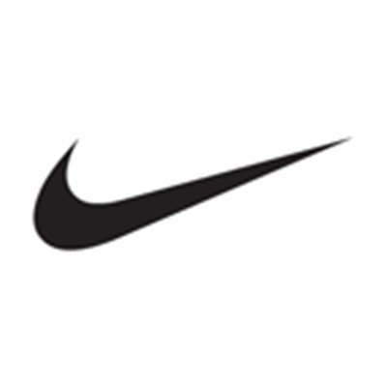
Picture source: Google images

# 7 Reason for having a perfect logo:

It’s not just a picture. A cleverly designed logo can convey your company’s mission/ goal/spirit etc much better than a carefully drafted company introduction. Take a look at the logo below. I don’t have to tell you what HEGA is trying to sell, do I? It’s all in the picture.

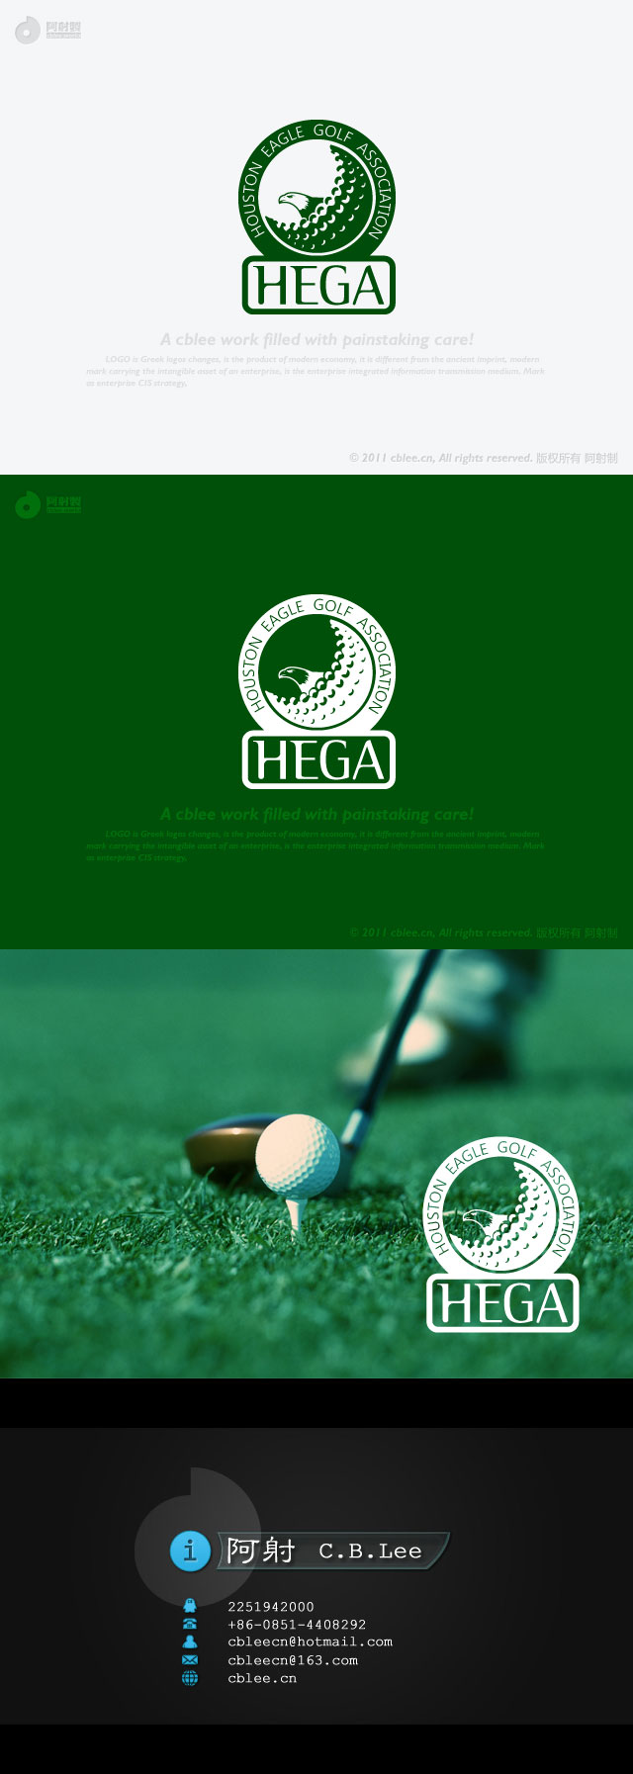

Picture source: http://www.witmart.com/jobs/Logo-Design/LOGO-design-Houston-Eagle-Golf_1431.html

# 8 Reason for having a perfect logo:

It’s the simplest form of advertizing. You don’t have to fork out thousands of dollars trying to direct an informative yet non-boring TV ad. An eye-catching logo on every product you sell is a subtle yet powerful form of advertizing in itself.

# 9 Reason for having a perfect logo:

A professional-looking logo will hint to your clients that your company is serious about doing business and will not waste away the clients’ money.

# 10 Reason for having a perfect logo:

Well, why do women always want to buy new dress and new shoes? It makes them feel good. So why do you need a fresh and perfect logo? It makes you feel good.

However, having a perfect logo is always easier said than done. Most of us small business owners do not have the time and/or expertise to design a good logo by ourselves.

Why not consider a logo design contest? There are now websites that outsource such services, one being witmart.com, where you can put up a job describing what you need, and talents worldwide will start working for you.

It is also super easy to do it. George Lee, author of the monthly George’s Corner in the Southern Chinese Daily News, is one of the pioneers who have leveraged on the witmart platform to turn his popular column into a TV program. He simply posted a logo design contest job on witmart asking for the best logo for his program, and hey presto, he got 79 different proposals. In the end, he picked the best one and paid 200 bucks.

So you see, besides the pool of talent (where else can you get 79 highly qualified designers worldwide to work for you?), it is also much cheaper than hiring a design company to do it.

Moreover, the whole contest took only two weeks. Instead of working himself to the ground trying to do it himself, Lee was probably sipping latte while he waited for the best logo to come forward.

Lesson learnt: it doesn’t matter how big or small your business is, nor does it matter what the nature of your product is. As long as you have a need for a perfect logo, there is always someone out there who could do it for you. All you have to do is just post a contest.

