Chanel fall 2012 nail polish colors Vertigo, Suspicious and Frenzy are revealed
2012 香奈儿秋季三款指甲油正式发布——Vertigo， Suspicious & Frenzy

2012香奈儿秋季指甲油现已入驻各大商场专柜，色彩分别为： Vertigo， Suspicious 和 Frenzy。
Chanel’s fall 2012 nail polish has hit store shelves and the hues, Vertigo, Suspicious and Frenzy, are

它们正在引领2012秋冬两季的潮流。
right on trend for the fall and winter 2012 season. Chanel has created three hot colors for fall

香奈儿已经为秋季打造了三款热门的颜色，包裹指甲油， Frenzy。
including the nail polish color, Frenzy, which created quite an internet stir when it

Frenzy一出现在香奈儿巴黎时尚周 2012/2013 秋冬成衣秀的舞台上时，它就创造了一个网络热词
appeared on the runway in Chanel’s fall/winter 2012/2013 Paris Fashion Week, ready-to-wear show.

2012秋季指甲油有裸色，深棕色和经典的红色
Nail polish for fall 2012 is being shown in neutral nudes, dark browns and classic shades of red.

Vertigo 是带有明亮闪耀光泽的深棕色指甲油。它完美的将秋季传统颜色与中性服装色彩结合在一起。
Vertigo by Chanel is a deep, dark brown with a light, sparkling which is perfect for pairing with fall’s

第二款，Suspicious 是带有浅粉色的枣红色指甲油，既经典又新潮。
traditional color palette and neutral apparel hues. The second nail polish color, Suspicious by Chanel

最后一款，Frenzy自香奈儿2012巴黎时尚周亮相以来已经成为网络热词，
is a purplish red with pink undertones which is classic and slightly edgy. The last color, Chanel Frenzy, which became an Internet sensation after appearing on Chanel’s fall 2012 runway during

Frenzy是裸灰色指甲油，它呈现一种冷静的外观，能很好的和秋季各种成衣的颜色混合在一起。
Paris Fashion Week, is a grey-nude which offers a cool look and will easily blend well with any color palette for fall.

Suspicious 和 Frenzy 都是单调的颜色，并不会过去几季香奈儿指甲油那样呈现同样的闪耀光彩。
Suspicious and Frenzy are all flat colors and do not offer the same sparkle which has been

Vertigo ，正好相反，它加入了棕色调，使其呈现低调的闪耀。
appearing on Chanel nail polish over the course of the last few seasons. Vertigo offers a slight sparkle which adds dimension to the otherwise, dark nature of the hue.
正当Vertigo 和Suspicious 难以置信的引领2012秋季潮流之时，香奈儿Frenzy期望成为2012秋季
While Vertigo and Suspicious are on-trend and fabulous for fall 2012, Chanel’s Frenzy is expected to

潮流色。裸色指甲油是秋季热门的颜色，它一再纽约，米兰，伦敦和巴黎的时装展上
be the frontrunner and “IT” color for the fall 2012 season. Nude nail polish is hot for fall and was

被众多设计师所关注。
spotted on the runways in New York, Milan, London and Paris by various designers. Beauty

当我们谈论之时，美容公司们已经成功开创了自有的2012秋季裸色指甲油，
companies have also been creating their own versions of nude nail polish for the fall 2012 season

它们已经成功登陆各大百货的专柜。自香奈儿的Frenzy成为网络热词以来，
which are arriving on store shelves as we speak. Since Frenzy by Chanel has already created quite

裸色指甲油成为即将到来清凉季节的流行色。
an internet stir, and nude polish is all the rage this upcoming cool weather season, the nail color is

该款裸色指甲油必定会再本月大卖，因为裸色指甲油的粉丝和香奈儿迷们会蜂拥进入各大百货专柜
bound to sell out this month as nail polish fans and Chanel addicts flock to store shelves to purchase

抢购属于自己的2012秋季香奈儿Frenzy裸色指甲油。
their own bottle of Chanel Frenzy nail polish for fall 2012.

香奈儿Frenzy和香奈儿 Suspicious对于现在在夏季穿上点秋意服装的人来说是很完美的指甲油。
Chanel Frenzy and Chanel Suspicious are perfect nail colors for wearing a little bit of fall right now

Suspicious，复古的红色和 Frenzy，淡的裸色使这两款指甲油能够很好的
during the summer. The classic red hue of Chanel Suspicious and the light, neutral nature of Chanel

和秋季或者夏季服装的颜色搭配起来。
Frenzy allow the two nail polish colors to easily be paired with summer or fall colors palettes. Chanel

香奈儿的Vertigo事深棕色，这使它成为秋季传统的色彩。当超级时尚迷们开始将他们的衣柜的衣物
Vertigo is dark brown, which makes it more of a traditional fall color that will work well at the end of

由温暖的夏季服装过渡到温暖但比较温和的秋季成衣的时候，Vertigo将在八月末将这一过渡变得顺畅。
August as Fashionistas everywhere begin to transition their wardrobe from warm summer weather clothing to apparel which is perfect for warm yet mild fall temperatures.

香奈儿Vertigo， Suspicious 和Frenzy指甲油 毫无争议的是由地球上最好的色调制作而成。
Chanel’s Vertigo, Suspicious and Frenzy nail polish are made with arguably the best pigments on

Vertigo， Suspicious 和Frenzy 只需要和两件外套就能完全的，完美的，毫无痕迹的结合起来。大爱！
earth. Vertigo, Suspicious and Frenzy only need to be applied with two coats for complete, perfect and streak-free coverage. Love that!

香奈儿的Vertigo， Frenzy和Suspicious 可以再香奈儿全球旗舰店以及Nordstrom, Neiman Marcus, Bloomingdale 和 Macy 百货可以购买到。
Chanel’s Vertigo, Frenzy and Suspicious can be found at Chanel boutiques globally as well as Nordstrom, Neiman Marcus, Bloomingdale’s and Macy’s stores.

如有任何问题请加 我的QQ 1846467958
Any question? Please add my QQ 1846467958.
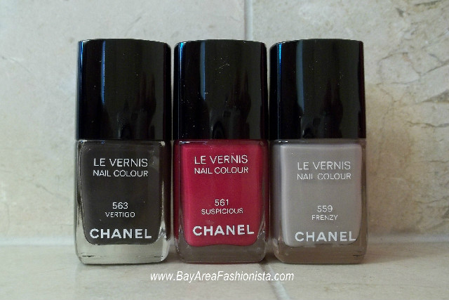
Photo: Chanel Vertigo, Suspicious and Frenzy
Photo Credit: Cathy/Bay Area Fashionista

